Curricular Vitae
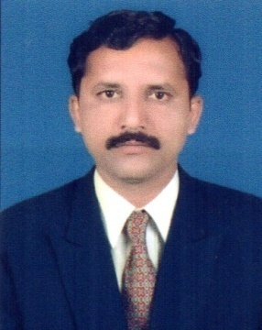
Personal Profile:
Name : Dr. AmolShrikantKamble
Communication Address: A/P – Nej (Shahunagar)
Tal. – Hatkanangale
Dist. – Kolhapur 416110.
Cell No.: 9921245745
E-mail ID: as84kamble@gmail.com
Date of Birth : 9th May, 1984
Marital status : Married Language proficiency: Marathi, Hindi & English.

Educational Qualification:M. A., M. Phil., Ph. D., SET (Economics)
Program | Board/University | Year of Passing | Percentage | Grade/Class
S. S. C. | Pune Board | March, 1999 | 53.60% | II Class
H. S. C. | Pune Board | February, 2001 | 62.17% | I Class
B. A. | Shivaji University, Kolhapur. | April, 2004 | 62.22% | I Class
M. A. | Shivaji University, Kolhapur. | April, 2006 | 68.50% | I Class
M. Phil. | Shivaji University, Kolhapur. | April, 2009 | -- | A Grade
SET | UGC Recognized Conducted by S.P. University, Pune. | May, 2016 | Qualified
Ph. D. | Shivaji University, Kolhapur. | July, 2017 | Awarded

Teaching Experience:10 years
Current Position: Assistant Professor, Department of Economics, Dr. Patangrao Kadam Mahavidyalaya, Ramanandnagar (Burli) Dist. Sangli.
Area of Research: Research Experience: 10 years
Title of Ph. D. thesis:“Impact of Government Schemes on the Socio-economic Conditions of Scheduled Caste Communities in Kolhapur District”
Title of M. Phil Dissertation:“Rural Environment: A Study of Hatakanangale Taluka”
Research Projects submitted to Shivaji University, Kolhapur:03
Research Paper Published | Seminar Proceeding | Journals | Journals with Impact Factor | UGC Care listed Journals | Total
 | 03 | 03 | 01 | 00 | 07

Paper Presented | International Seminar | National Seminar | State Level Seminar | Total
 | 00 | 06 | 01 | 07

Participation of Seminars, Workshops & Webinars | International Level | National Level | State Level | Webinars | Total
 | 02 | 11 | 21 | 57 | 91

Co-curricular activities:
Secretary of National Seminar:01
Committee Members in College:IQAC, Criteria VI & Criteria V.
Worked as: SRPD Sr. Supervisor, Internal, External Sr. supervisor, Jr. Supervisor & Examiner of University examination.
Delivered NET-SET lecture:01
Participation of Awareness quiz Program of COVID 19:35

(Dr. Amol S. Kamble)

